Vendor Information Package

Map of the festival enclosed for your reference

Prior to the Festival
- The festival will proceed as planned regardless of the weather so please come prepared for any situation.
- Please remember to bring your payment receipt / booth confirmation # with you on festival day which will be mailed to you by the end of March.
- Vendors are responsible for having their own liability insurance. Be prepared to show proof of insurance.
- If you are a food vendor and will be cooking or selling food products from your booth all health rules and regulations must be met. You will be required to obtain a “Special Occasions Permit” from the Collingwood office of the Simcoe County District Health Unit. This permit is to be displayed in your booth. You can reach the Health Unit office at (705) 445-0804.
- If you are a food vendor requiring a “Refreshment Vehicle License” for commercial equipment, you may obtain further information and arrange inspections by contacting The Township of Springwater, 2231 Nursery Rd, Minesing, ON L0L 1Y2 or phone 705-728-4784. Please contact the Township prior to April 1st to ensure compliance.
- You are encouraged not to bring your family pet to the festival. Dogs will not be permitted to be tied up at your booth location.

Day of Information
- NEW: ALL VENDORS MUST CHECK IN VENDOR VOLUNTEER PRIOR TO SETTING UP. The EMSF booth is located inside the arena in Vendor Spot #1 just inside the main entrance.

- All inside vendors in the arena, you can set up on Friday from 4pm-8pm, and again Saturday 6:00am. You can use the front entrance or the ones the side of the building.

- All outside vendors are welcome to start set up at 6:00 am on the Saturday. After you have unloaded, please park in the vendor parking located at the rear of the arena.
- Maria Street North from Queen Street to the Arena and Fairgrounds entrance will be closed to local vehicular traffic starting at 6:00 am. This is to allow vendors safe access to their booth set up areas. Booths must be fully set up and functional by 8:00 am when the Festival officially opens to the public
- Booth set-up guidelines must be strictly adhered to due to fire and safety regulations/restrictions dictated to us by township and county officials. No Overhangs outside allotted booth dimensions will be allowed.
- All equipment, displays, supports, signs, etc. must remain within the allotted booth dimensions.

- Parking: Vehicles remaining in the booth as part of the booth set-up must stay within the allotted booth dimensions. All other vehicles and oversized vehicles will not be permitted to stay on site and can be moved to the vendor parking area. Springwater Township will be enforcing no parking along the west side of Amelia Street, the south side of Stone Street and the north side of William Street. The streets will be clearly marked by the Township as tow-away zones which will be strictly enforced Parking at the Festival on Festival Day. Special vendor parking will be located behind the arena. [see map] If you have any questions, please do not hesitate to approach one of our volunteers.

- Only those vendors registered with the Elmvale Maple Syrup Festival organizers and approved will be allowed to operate a business on the day of the festival providing they adhere to all fire, safety, and health rules and regulations. Space sharing by two (2 ) businesses or vendors is strictly prohibited.

- Washroom locations are as follows:
  - Pancake House located in the Elmvale Community Hall at 35 Queen Street West
  - Porta Potty located along Maria Street
  - Arean Washrooms located inside the main doors of the area beside the concession stand in the south east corner.

- The official “Pancake House” is located in the Elmvale Community Hall at 35 Queen Street West. Pancakes with maple syrup and sausages are served all day long for a nominal fee from 8am – 3pm.
Tear Down Information
- Vendors must remove their booth set-ups, clean up their sites and vacate the street area prior to 6:00 pm when the streets will be reopened to local vehicular traffic. Public Festival Hours are 8am-5pm.
- Vendors are responsible for keeping their booths clean and free of all garbage and other waste materials. Although garbage receptacles will be placed throughout the area for public use, you are to be responsible for your own waste materials, take it home with you. This includes empty boxes, papers, cardboard, your own garbage, etc..
The Elmvale Maple Syrup Festival Association hopes you have a great day and will follow these simple guidelines that have been set out for you. Festival staff members wearing coloured vests or jackets and carrying identification will be on hand throughout the day to assist you. Please cooperate with these staff members to make this year’s festival successful and enjoyable for all.
Thank you,
The Elmvale and District Maple Syrup Festival Association.
For further information Email vendors@emsf.ca
Reminder: With your application you signed off confirming that “The Applicant agrees to save harmless The Elmvale and District Maple Syrup Festival Association and their committee members at all times from any claim of any kind or nature whatsoever in law, equity or otherwise arising out of or indirectly resulting from the construction, operation or maintenance of the applicant’s operation at the Elmvale Maple Syrup Festival”.

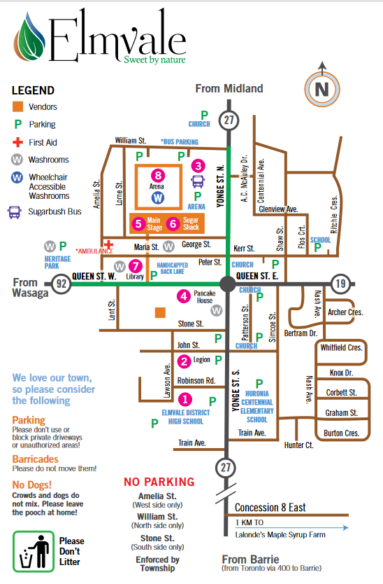
VENDOR PARKING

